- Label the following diagram showing the amplitude, frequency and wavelength.
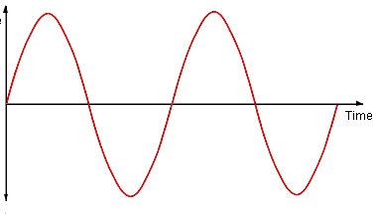
- Give the frequency. (Don’t forget the units!)
  - 2 Hz
- What does the amplitude show?
  - How loud the sound is
- What does the frequency show?
  - The pitch of the sound
- Complete the following examples.
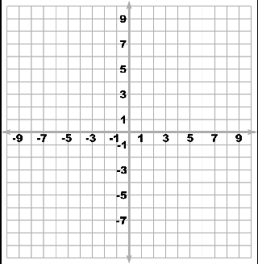
A loud, low pitched sound. | A soft, high pitched sound. | A loud, high pitched sound fading.
What is the frequency? | What is the frequency? | What is the frequency?

